**PMWebSpec Application Setup User Guide**

# **Application Introduction –**

PMWebSpec is a Web Based Application developed using CodeIgniter based PHP Programming language (Version 5.5 – 8.0). Frontend is developed in HTML5, CSS, JavaScript, Bootstrap and MySQL as database.

# **Application Architecture –**

**Backend** - PHP CodeIgniter (MVC Structure)

**Database** – MySQL

**Frontend Tech** – HTML5, JavaScript, CSS, Bootstrap

# **Software Required –**

## **Local Setup –**

*Note: - The installation process is specific to Windows OS and steps may differ for other operating systems.*

* Xampp Server (PHP 8.0 - Recommended)
* Any Editor (Sublime - Preferred) **- Optional**

### Xampp Server Setup: Installing this Xampp server will install both PHP and MySQL database.

* 1. Download Xampp server from <https://www.apachefriends.org/download.html>

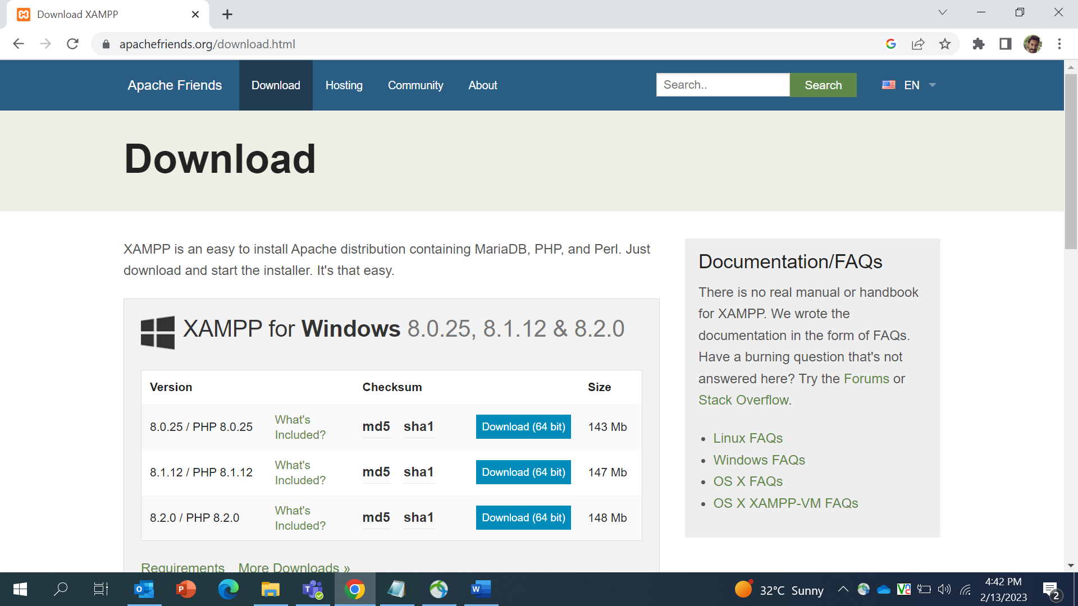

* 1. Download and install exe file according to the operating system
* Preferred installation location is C:\ drive
* After successful installation of Xampp, System will generate auto created folder named ‘xampp’ in **C:\** location
  1. Start Apache and MySQL server from toolbar

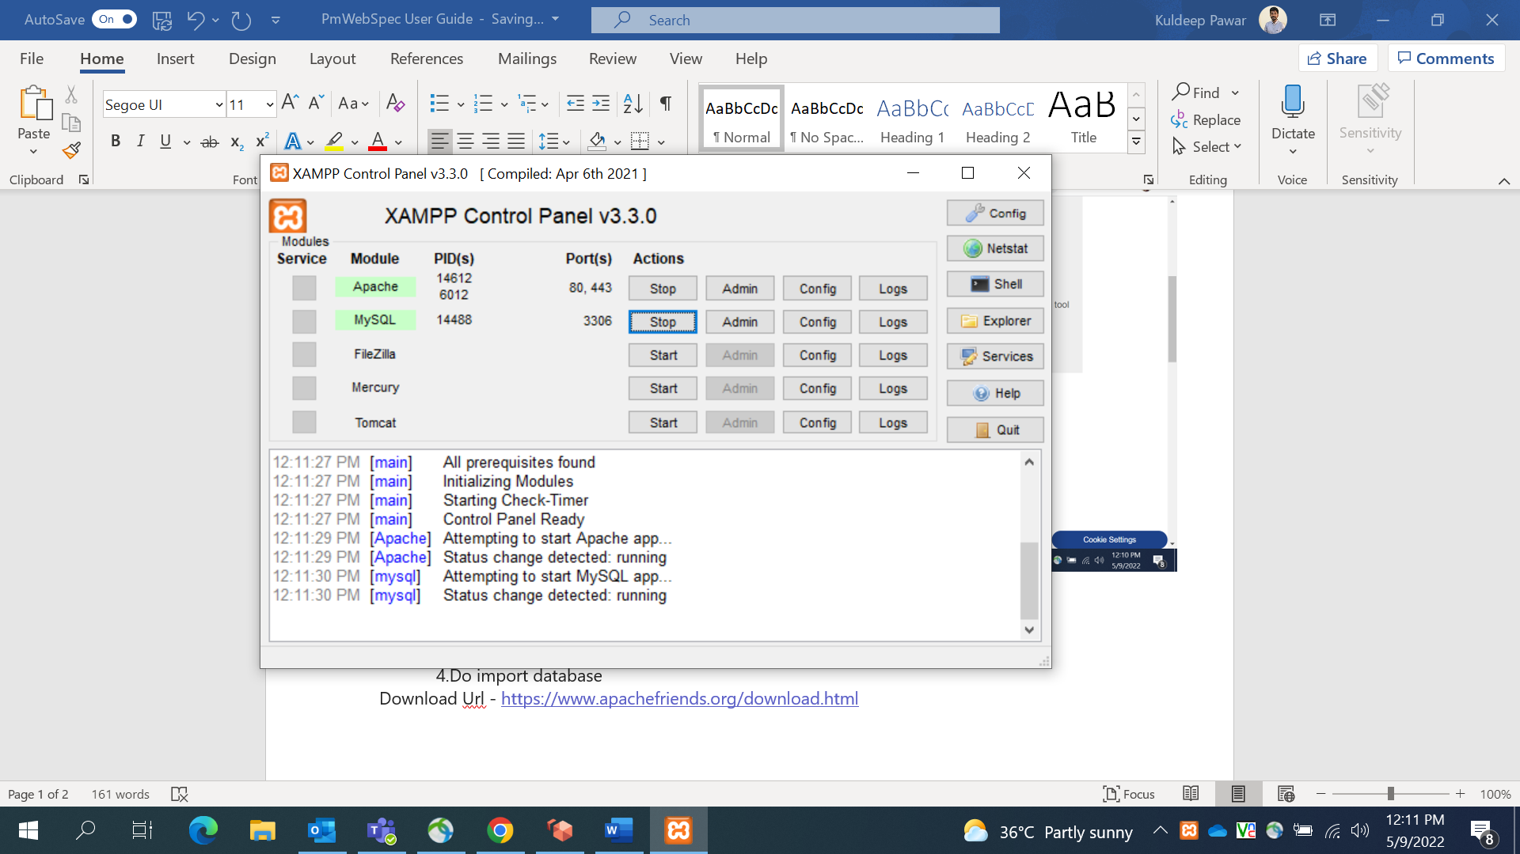

* 1. After Xampp setup and application server is started, import databases.

### **Database Configuration:**

**Databases** – PMWebSpec contains two databases

* dbstruct_ci_test
* web_based_spec_ci_test

**Steps for importing Database –**

1. Go to PhpMyAdmin page (<http://localhost/phpmyadmin>)

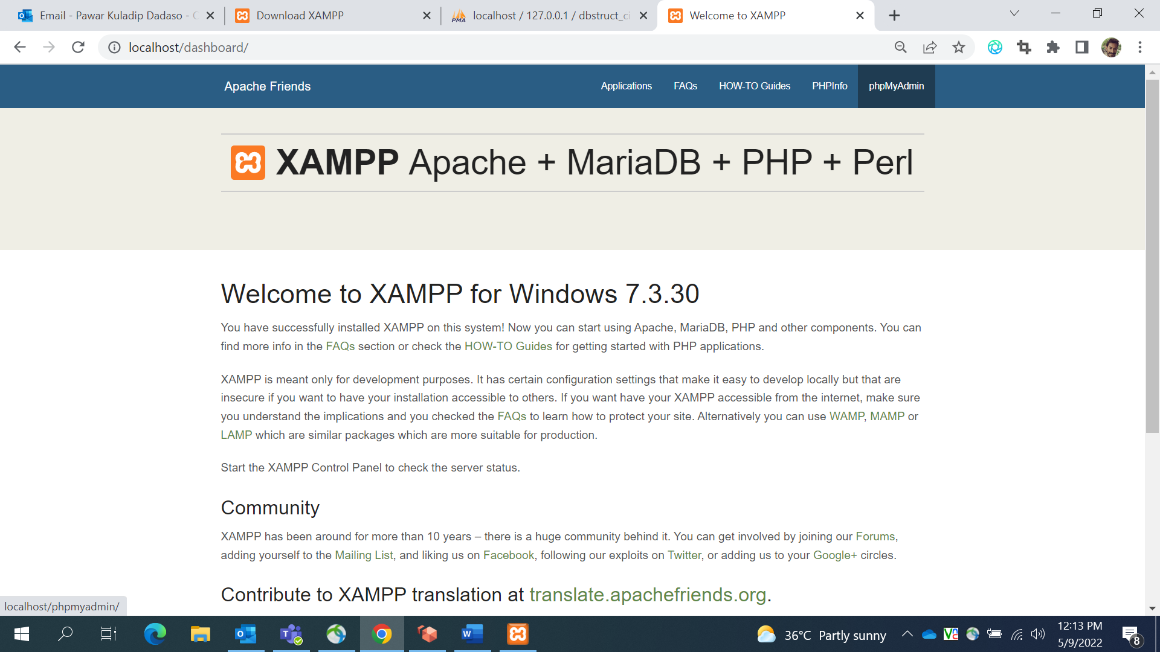

1. Create Database – dbstruct_ci_test and web_based_spec_ci_test

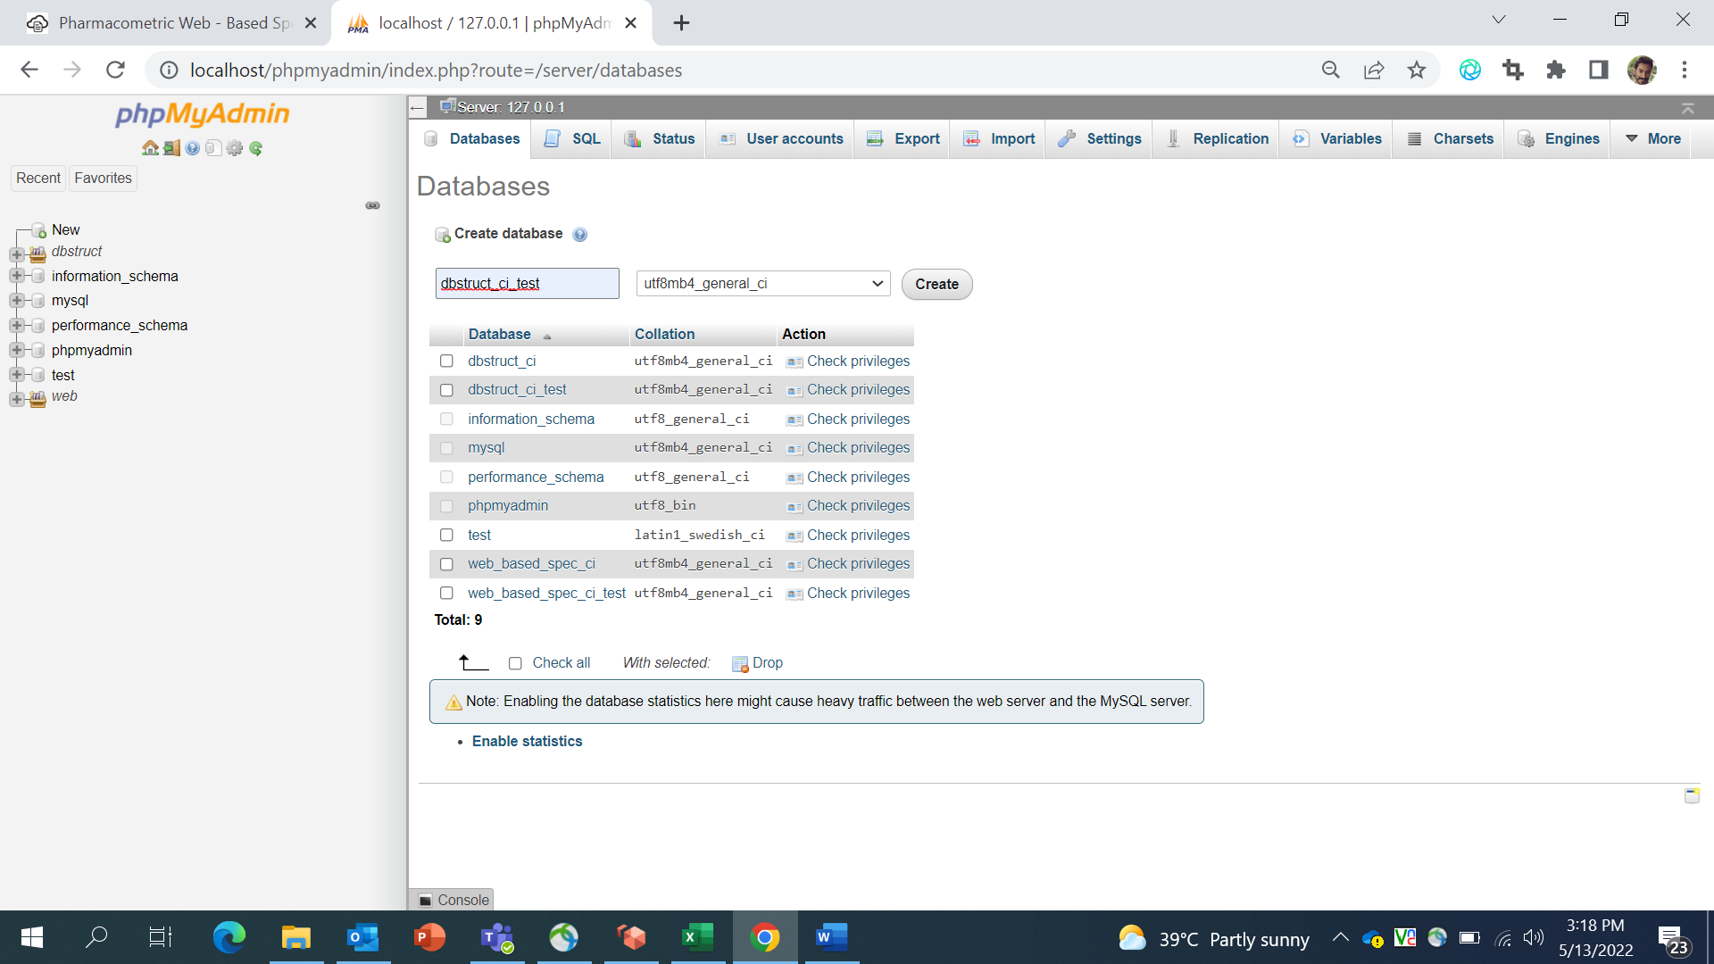

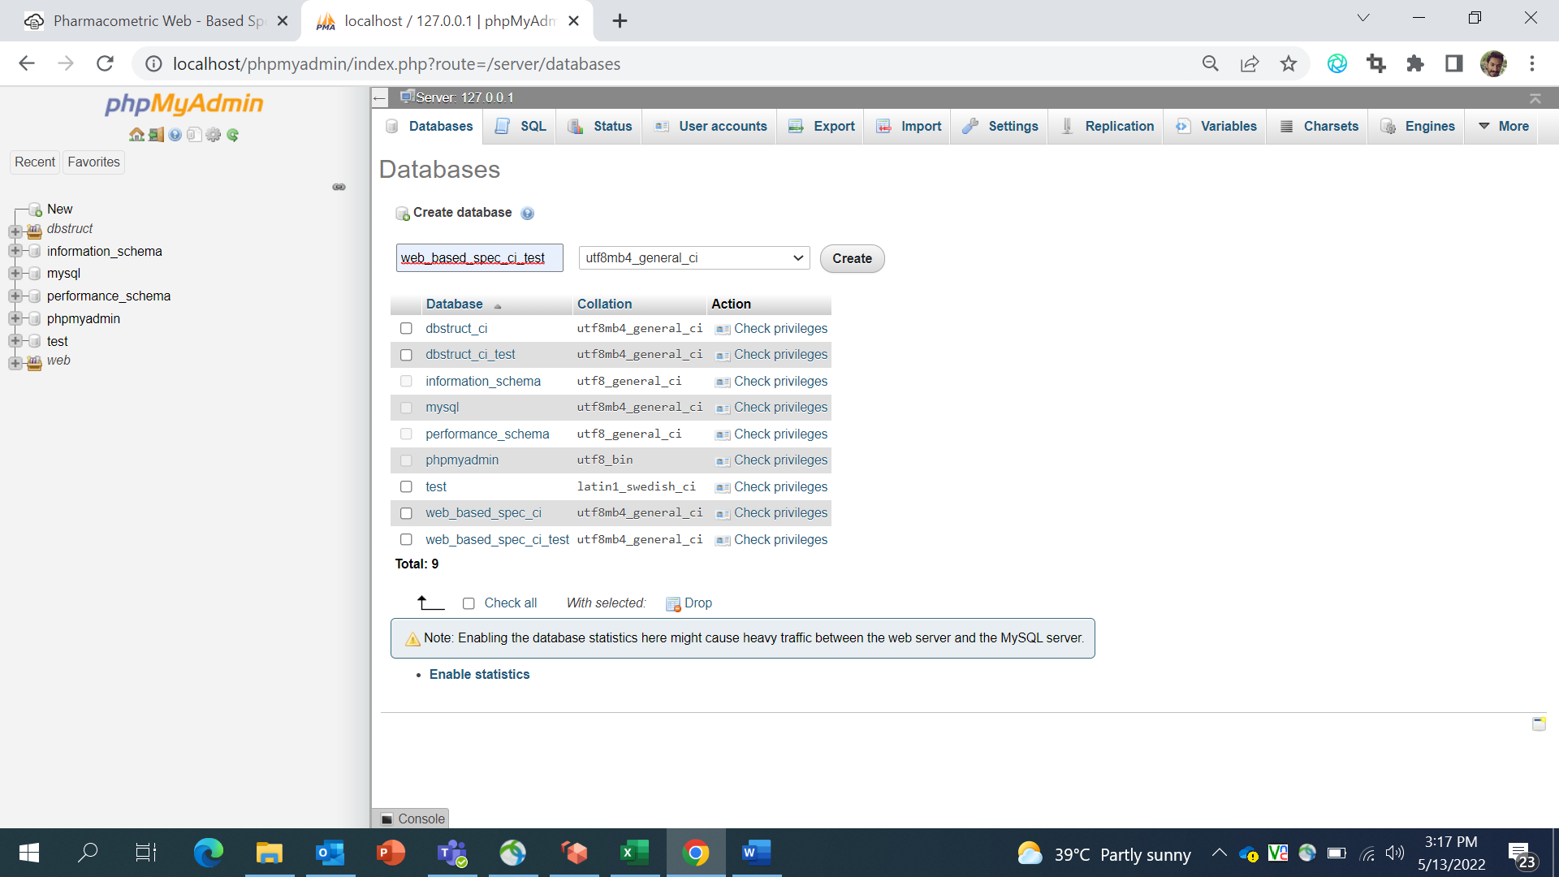

1. Go to Import tag and choose sql file as per database name from the “PMWebSpec/Database” directory

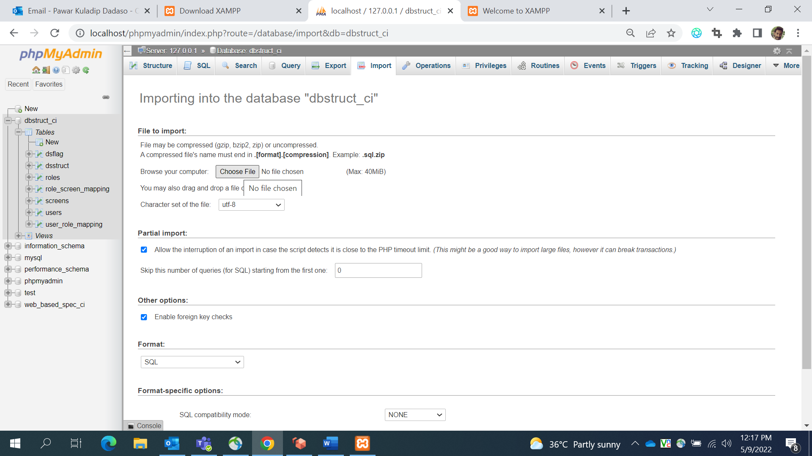

1. Click on the “**Import**” button at the bottom of the screen to submit

## Code Setup –

* 1. Create **“PmWebSpec_dev”** folder in **C:\xampp\htdocs\** location
  2. Copy the contents of **PmWebSpec_dev** from GitHub to the “**PmWebSpec_dev**” folder that you just created.

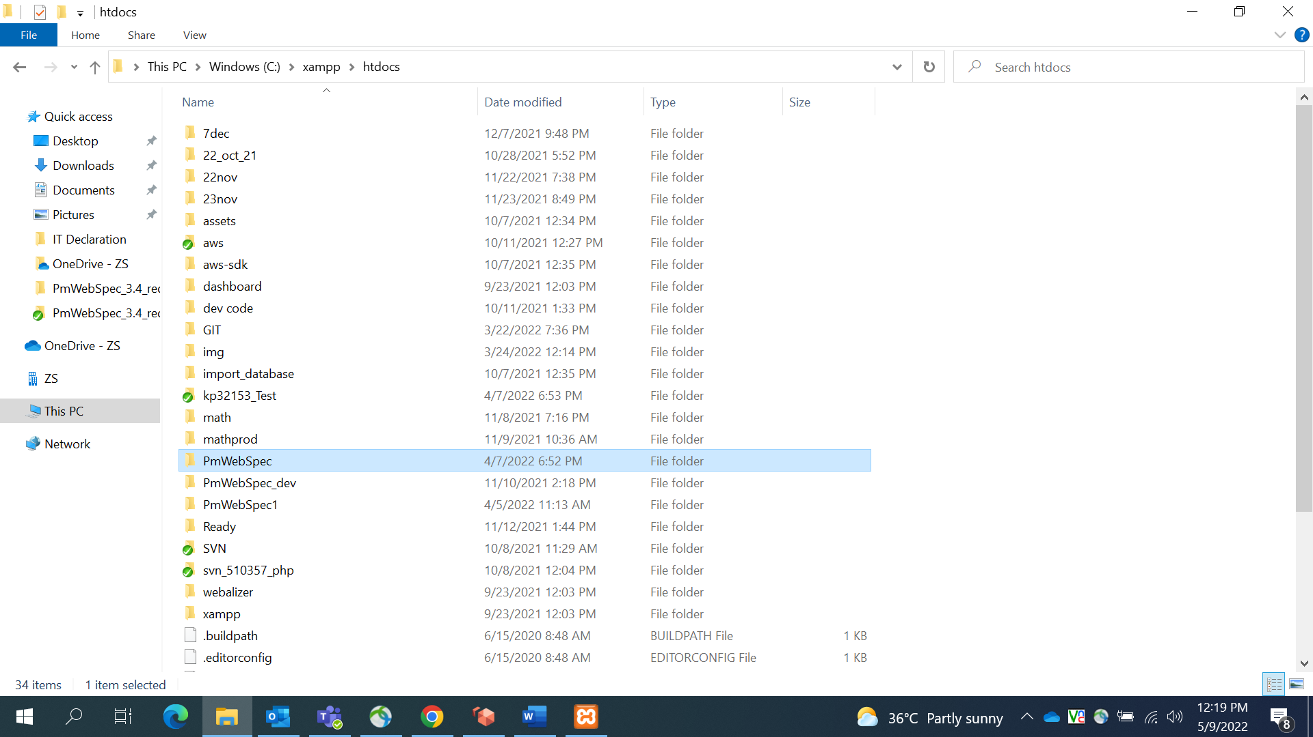

* 1. Configure databases into localhost and accordingly set database credentials in database.php file. the file available in **C:\xampp\htdocs\PmWebSpec_dev\pframe\config\** folder.
  2. To grant all access rights for pmwebspecadmin in local system, execute the below mentioned command in dbstruct_ci_test database in the “SQL” tab and click on “Go” button.

**GRANT ALL ON *.* TO 'pmwebspecadmin'@'%' IDENTIFIED BY 'complex-password';**

* 1. Run the application on local using the URL - <http://localhost/PmWebSpec_dev/home>

